# Process Document

Contents

Process Document 1

1. GitHub Setup 2

2. Visual Studio Build 3

3. Unreal Engine Crash 4

4. Finding the Hitch 5

5. Move Function to C++ 6

6. Retesting the Hitch 7

7. Package Game 8

8. Testing Packaged Game 9

## GitHub Setup

Created a GitHub repository for the Sportable Case Study.

While doing the initial push of the project, a warning message popped up about files too large, which the LFS (Large File Storage) for Git had to be configured.

To configure the LFS, I had to run the “Git Bash Here” in the folder which the repository project is.

The next few commands had to be executed.

git lfs install

git lfs track "*.uasset"

Which have resolved the warning message, and I was able to push the initial project.  
  
<https://github.com/MrKewer/SportableCaseStudy>

## Visual Studio Build

Trying to run the project, it had the problem that the project needed to be compiled manually.

As for a new project on my computer, I had to delete all the extra folders and regenerate visual studio project files.

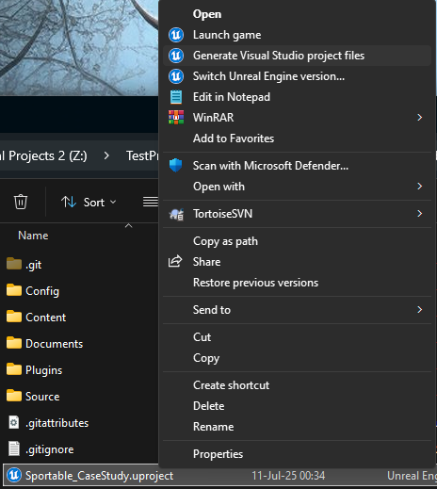

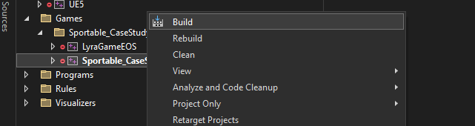

When doing the build, I received a compiled error message, which I stated that a function was incomplete. I went to the function and followed the instructions.

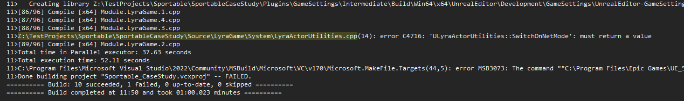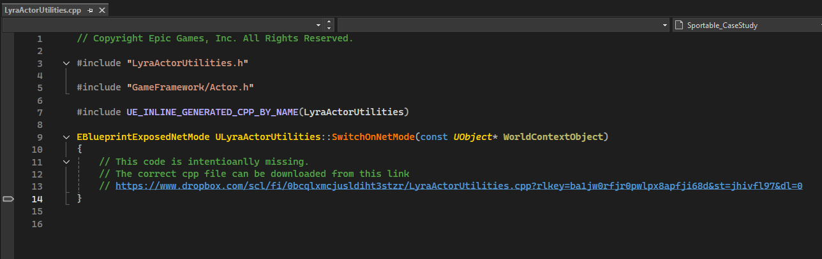

## Unreal Engine Crash

When trying to open the project, I had a GPU crash.

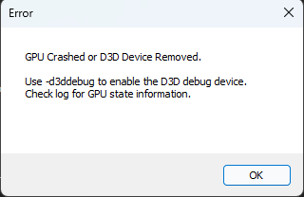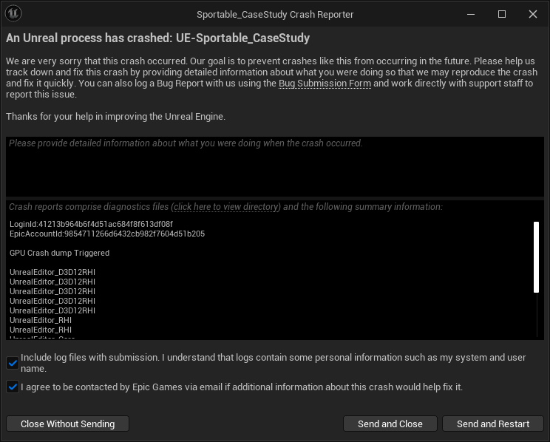

I knew this crash is related to Ray Tracing, this might only be related to AMD cards.

I opened up the DefaultEngine.ini file in the config folder and set the RayTracing to false.

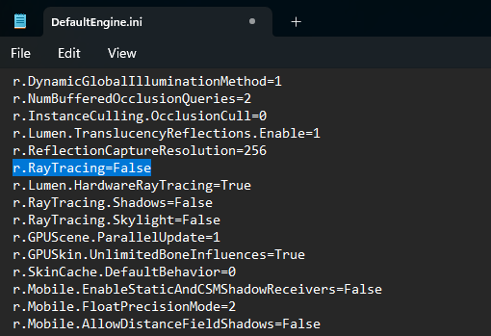

## Finding the Hitch

While testing the game in editor, I started tracing the Playthrough.

After the test, I have opened the trace in Unreal Insights, there it’s clear to see all the Hitches that have occurred.

When selecting one of the spikes, the function that is causing the frame drop shows in the “Callees” window. Which is the Item Power Calculator inside the B_WeaponSpawner Blueprint.

Opening the blueprint the function could be found in the Event Graph, otherwise a quick search will help.

## Move Function to C++

The function could be viewed in Blueprint

The function could be moved to the parent class of the blueprint, LyraWeaponSpawner.h

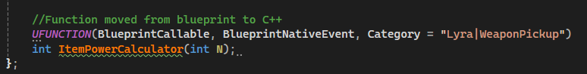

With the functionality coded in the LyraWeaponSpawner.cpp

After rebuilding the code, the function could be called in the blueprint and could replace the old function.

## Retesting the Hitch

To ensure the Hitch was resolved, another tracing of the playtest was done. And no hitches occurred.

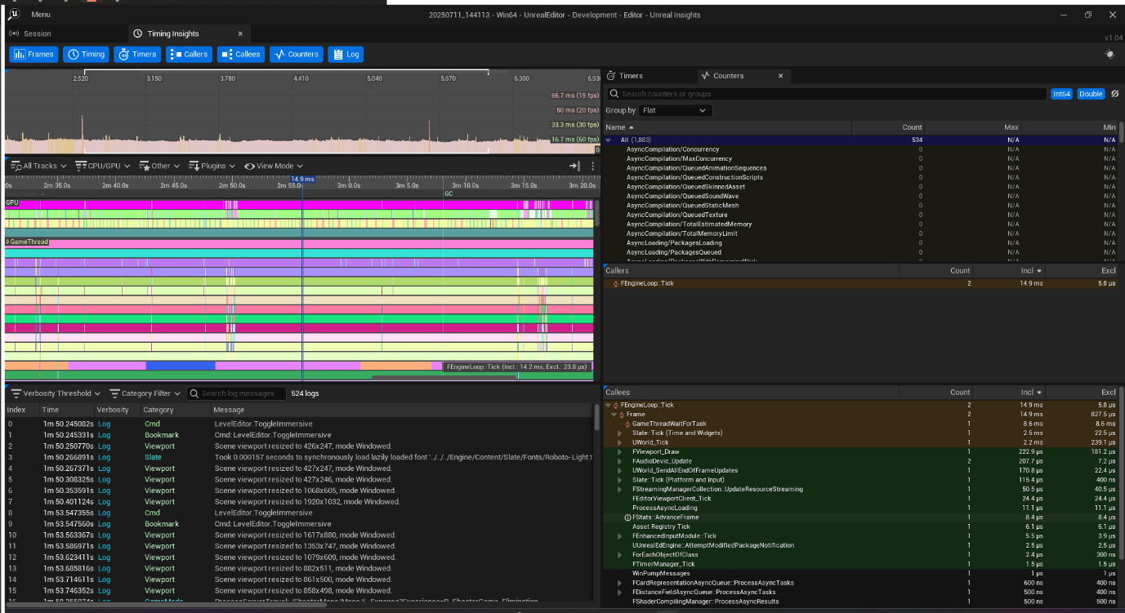

## Package Game

While packaging the game an error occurred.

This error states that MipGenSettings is not a member of UTexture2D, which is called in LyraAnimInstance.cpp line 45.

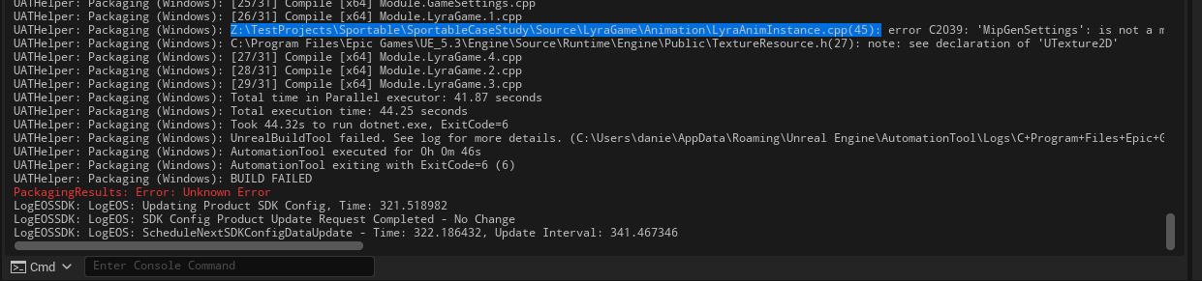

Viewing the file, it was stated that I can remove the texture.

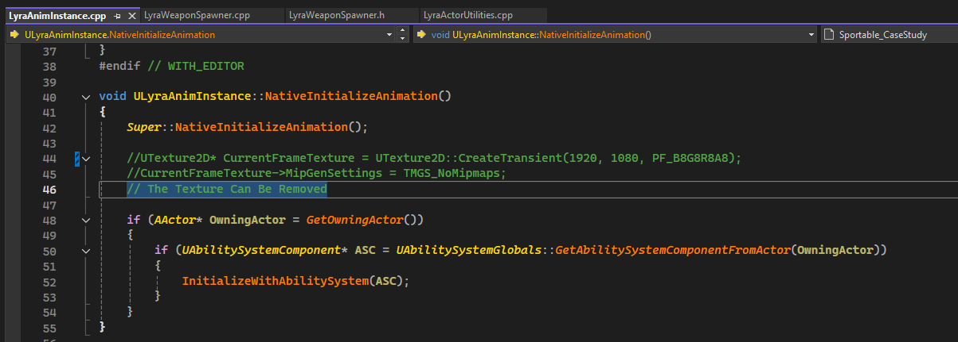

## Testing Packaged Game

Trying to run the packaged game, a system error message pops up, which is caused by nats.dll not being found.

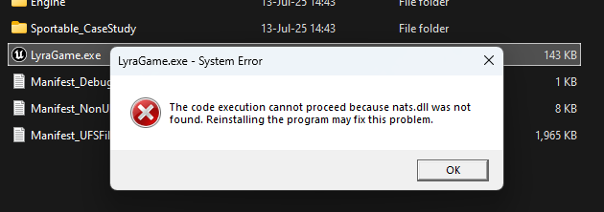

Searching through the plugins, a GBSNats was found.

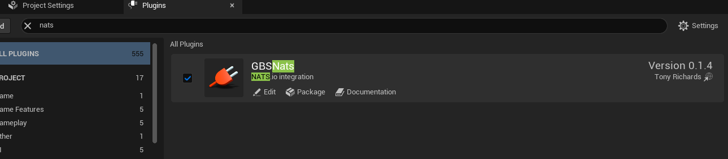

Looking at the documentation of the plugin, it was found that it should be used as a Linux Game Server, which for the testing purpose of this, I believe it is safe to say that I can turn off the plugin.

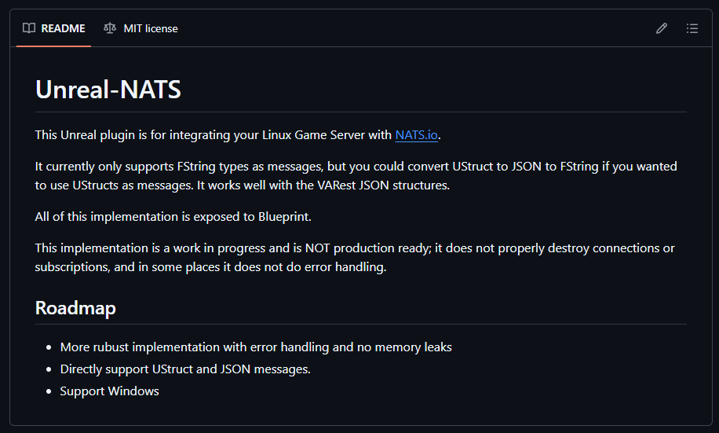

By turning off the plugin, the packaged game worked.